Safety- RAINBOW LAB

Background Information
Chemistry is a hands-on course that includes a good amount of lab work. Being successful in the chemistry lab requires following all safety rules and a great attention to detail when completing lab measurements, procedures, and calculations. This introductory lab will give you a chance to explore a challenge that allows you to practice these skills.

Task
Develop your chemistry lab skills by completing a challenge that tests your ability to measure precisely, follow directions, and practice lab safety procedures.

Safety
Avoid getting the substances on your skin or in your eyes. Goggles must be worn at all times. When mixing chemicals, remember to avoid cross contamination by cleaning your equipment every time you use a new substance. All substances may be safely poured down the drain.

Materials
- 6 test tubes
- 1 test tube rack
- 3 pipettes
- 1 beaker with RED liquid
- 1 beaker with YELLOW liquid
- 1 beaker with BLUE liquid
- 10 mL graduated cylinder, 2
- 25 mL graduated cylinder
- Safety goggles

Procedure - Part 1
- Label the six test tubes in order: A, B, C, D, E, and F
- Measure 2.5 mL of RED liquid and pout into test tube A.
- Measure 1.7 mL of YELLOW liquid and pour into test tube C.
- Measure 2.1mL of BLUE liquid and pour into test tube E.

Procedure - Part 2
- Measure 400 uL of the liquid from test tube C and pour into test tube D.
- Measure 700 uL of the liquid from test tube E and pour into test tube D.
- Measure 400uL of the liquid from test tube E and pour into test tube F.
- Measure 700uL of the liquid from test tube A and pour into test tube F.
- Measure 800 uL of the liquid from test tube A and pour into test tube B.
- Measure 300 uL of the liquid from test tube C and pour into test tube B.
- Observe the colors in the test tubes and record them in the data section.
- Measure the contents of each test tube (in milliliters) and record in the data table.

Data-Test Tube Observations
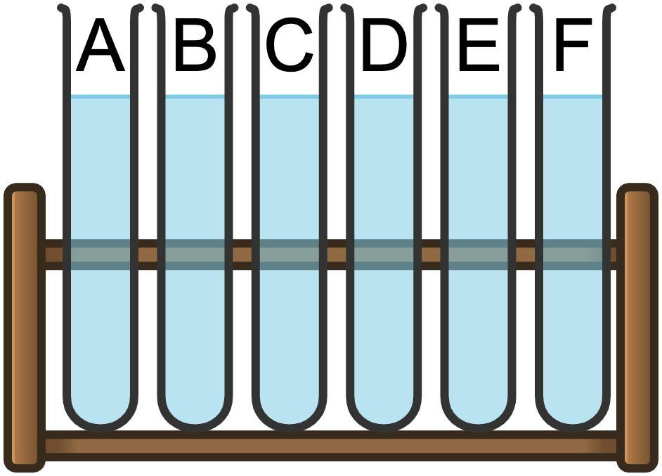

Test Tube | Color of Liquid | Volume Liquid (mL)  (Experimental) | Volume Liquid (mL)  (Accepted) | Percent Error (%)
A

B

C

D

E

F

Questions & Analysis
- Name the colors you created, in order from A to F.

- Experimental error often happens during laboratory experiments. What are some specific sources of error your group encountered during this experiment?

- Examine your hands, the lab table, your lab papers, etc. and look for stains from the colored lab solutions. The solutions in this experiment were made of water and food coloring, but how could this pose a safety issue if the substances had been hazardous chemicals?

